
School Board Advisory Committee Training
Patricia Minson, Division Counsel
Peter Noonan, Superintendent of Schools Rebecca Sharp, Executive Director

Thank you for joining us!

The work you do is important to us, our schools, and our community.
- Welcome & Introductions
- FAQ “Parking Lot”
- FCCPS School Board Advisory Committee Resource Guide
- Purpose of the Advisory Committees
- Roles of the Advisory Leaders and Members
- “Do This, Not That” for School Board Advisory Committees
- Charges, Focus Guide
- Next Steps
- Questions & Answers


Tate Gould,

Welcome & Introductions!
School Board Chair Kathleen Tysse,
School Board Vice-Chair
Peter Noonan, Superintendent
Share your name, role, and your favorite part of being of on an advisory committee.

FAQ Parking Lot
As you have questions, please jot them down and we will answer them.
We will also collect them and add them to the FAQ.

FCCPS School Board Advisory Committee Resource Guide



- Provide advice to the Board in their respective subject or areas of focus

Purpose of the Advisory Committees
- Make recommendations on issues or policies in order to help support the successful operation of the school division
- Represent the voice of a stakeholder in the community
- Share ideas and experiences to help support the Board and Division Staff with Programming


What are the roles on the advisories?
  - School Board Liaison
  - Committee Chair
  - Division Staff Liaison
  - Appointed Members


Review the information for your roles with your advisory partners.

- What did you already know about your role?
- What did you learn about your role?
- What questions do you have about your role?

Let’s play:
Do This…Not That!
Advisory Edition
We’ve all played or seen…



It is time for the meeting to begin, most people are there.

Let’s play..Round 1: Quorums

Do this:
Determine if you have a simple majority of voting members to hold the meeting. If you don’t you can hold the meeting but no business can be conducted.

Not that:

Hold the meeting without counting, everyone usually shows up.
You must have a quorum.

You receive an email from a parent sent to all members of the advisory.

Round 2: FOIA

Do this…
You respond thanking them for reaching out copying your Staff Liaison and board member–only.

Not that:
You reply all and set up a meeting with parent with another committee member to hear their concerns.
Don’t reply all and don’t get in situations that can be considered a meeting.

Two parents attend the meeting and share a concern about a teacher’s class and their student during public comments.

Round 3: Public Comments

Do this…
Let them speak if they followed the process for public comment. Let the Division Staff Liaison address the matter.

Not that:
Ask if any other members have had the same experience and discuss.
Don’t get involved in staff and/or student issues.

A member posts the minutes from a meeting on social media.

Round 4: Agendas & Minutes

Do this…
Remind them that their action doesn’t follow Policy 5.12 and ask them to take the minutes down until the Advisory has had a chance to review, revise if needed, and vote to approve the minutes.

Not that:
Ignore it.
Advisory approved minutes are posted on the webpage by the division.

A few more tips…

- Remember the “2 is a conversation and
3 is a meeting” rule
- Use the minutes from the meeting to help draft the annual report as a reﬂection of the work of the advisory
committee over the year
- Allow for time for Board Member Liaison and Staff Liaison Updates on
agendas
- Brush up on Robert’s Rules of Order
- Each year review policy 5.12 and bylaws (if the group has them) with members to ensure clarity of roles and purpose
- Welcome and orient new members

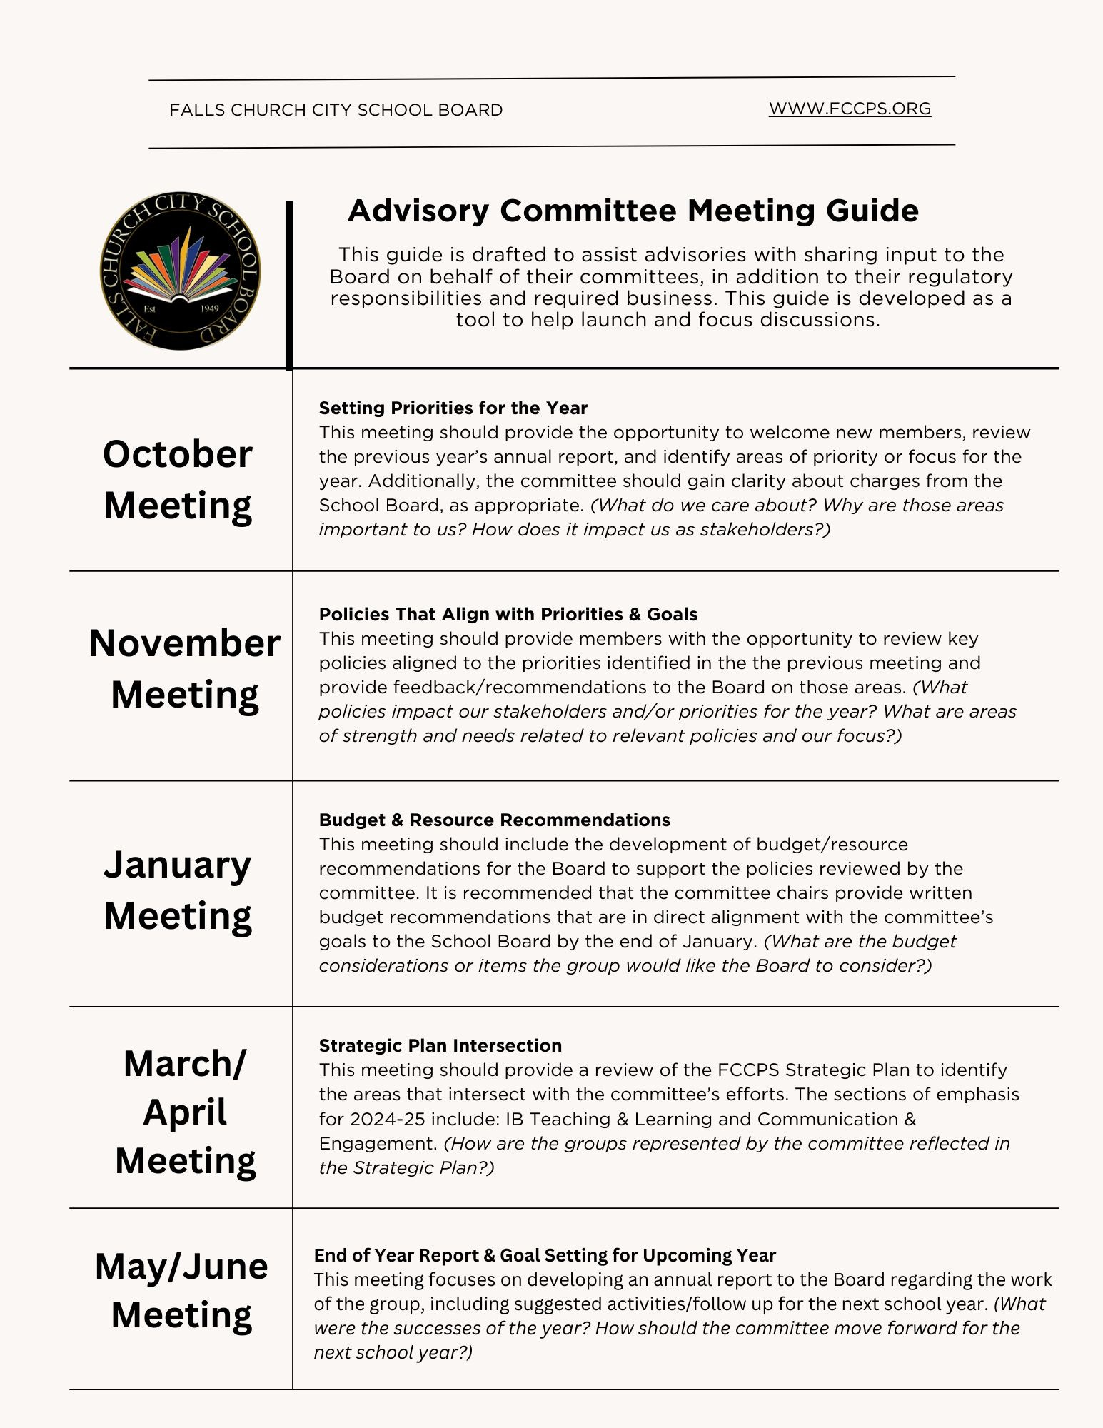
“New”Advisory Committee Meeting Guide
- Designed to assist advisories with their role of sharing input and recommendations from the lens of the stakeholders they represent to the Board
- Provides a suggested timeline for addressing focus areas, policies, and input on the budget
- Not to replace other required processes for the advisory committee



5 Components

IB Teaching & Learning
  - Wellness, Equity, & Belonging

Communication &
Engagement
  - Resource Management & Continuous Improvement
  - Investing in Our People

FCCPS Strategic Plan


  - IB Teaching & Learning
  - Resource Management & Continuous Improvement
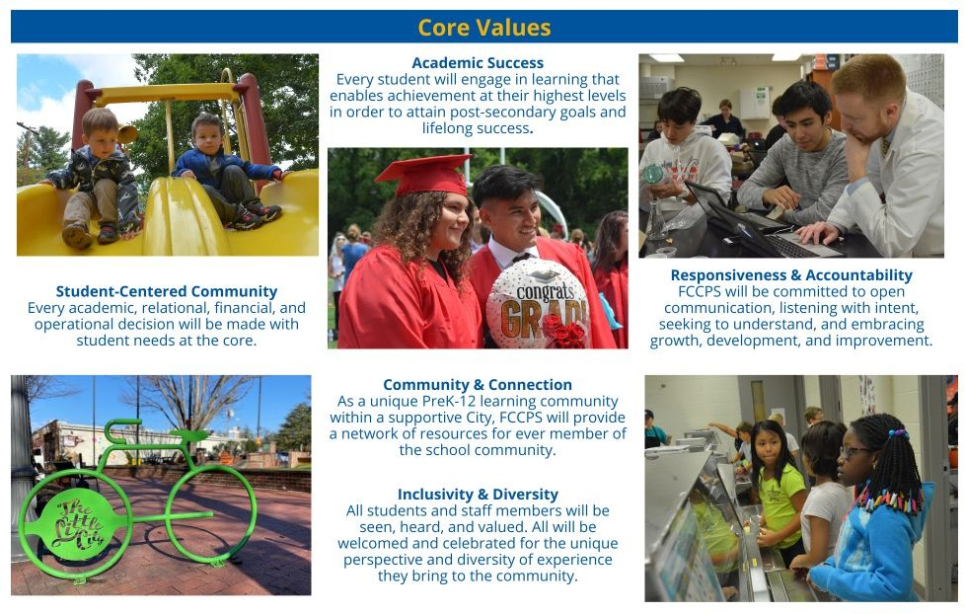
  - Wellness, Equity, and Belonging
  - Communication & Engagement
  - Investing in Our People

Strategic Plan Review Activity
    - IB Teaching & Learning and Communication/ Engagement are the focus areas for the year
    - Work as an advisory
team to review the strategic plan
    - Generate strategies your advisory can use to support this year
    - Be ready to share

Next Steps
- Review your meeting schedule
- Draft agenda for first meeting of the school year
- Include a review of the purpose of the FCCPS Board Advisory Committee and the Roles of the Appointed Members
- Use the focus/pacing guide and other tools for support

Thank you!
Have a great year!

